**Using Options**

I think ICT messed up the names and this one should be named "Valuation stock selection"

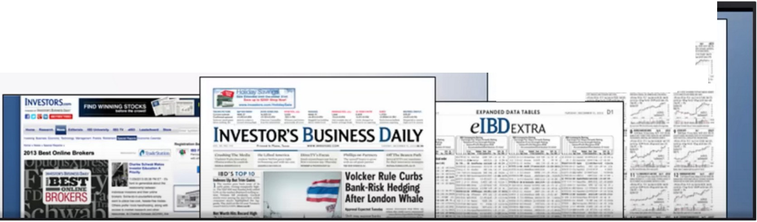

**INVESTOR'SBUSINESSDAILY**

II

**INVESTOR'SBUSINESSDAIL**"**Y**'

,- .. ,- **1-**

,- ....,.--. ·-· -

**..a *F.&*** -,_,,,...&

Have this as a resource/tool Great for fundamentals

How to make money trading stocks, book

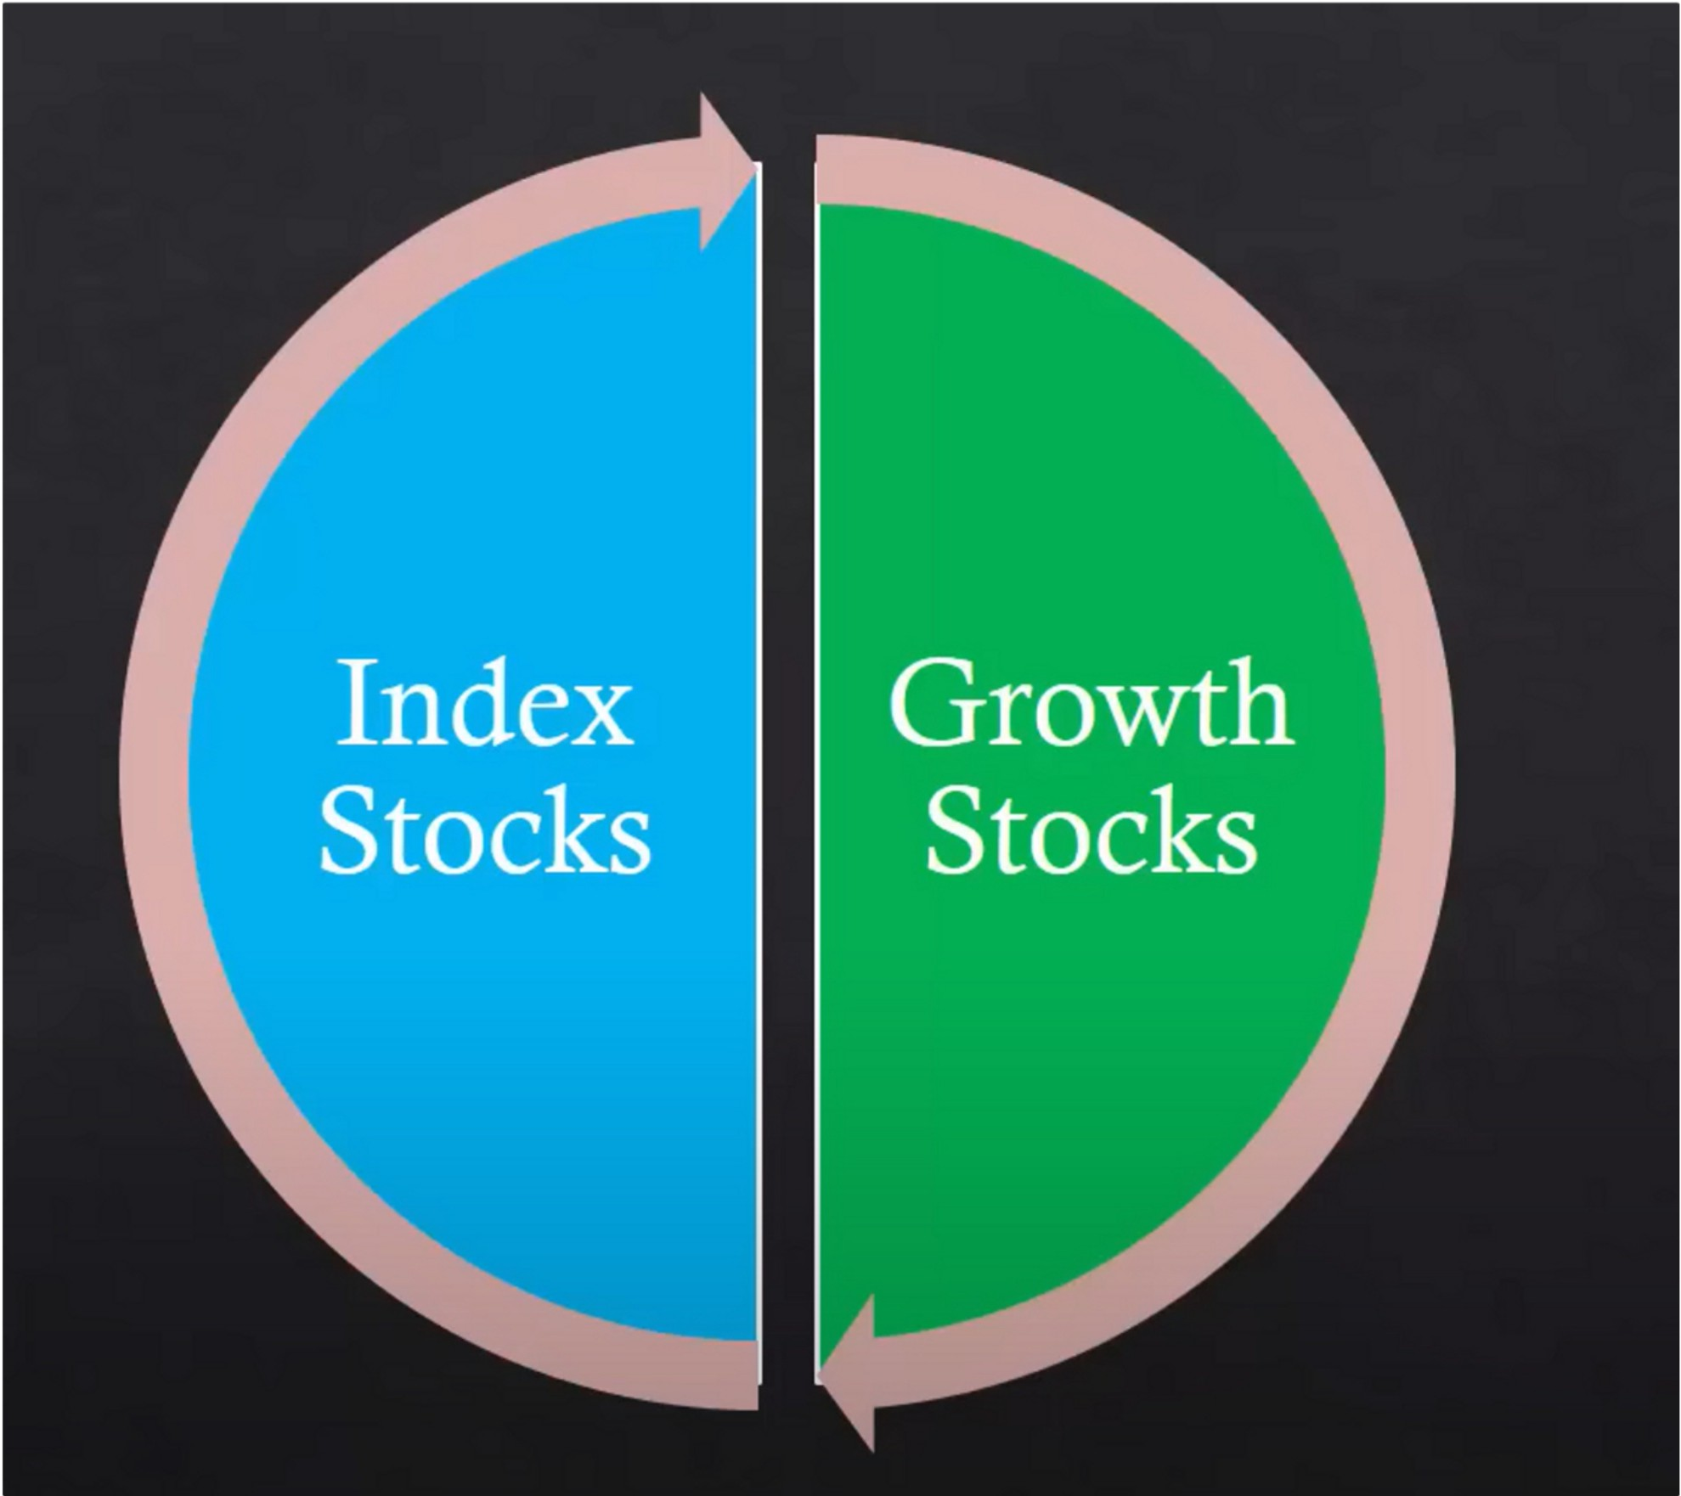

Were going to talk about valuation of growth stocks





**IC AN s L IM**

**C A N s L** I I **M**



**Current Quarterly Earnings**

**Current Earnings**

Annual Earnings

The New Supply Leader Institutional Market Factor and Demand vs. Laggard Sponsorship Direction

**C: Current Earnings**

Look for stocks with earnings growth of at least 25% in their latest reported quarter. Bigger growth is even better. You would also like to see earnings acceleration over the last three quarters For example, one quarter earnings may be up 25%. the next quarter up 50%. and the most recent up 90%.

# +25% or more in recent quarters

I ll lltl,1111, 111,1111 ',11, ,1 I, 111''

|  |  |  |  |  |  |  |
| --- | --- | --- | --- | --- | --- | --- |
| **C**  Current | **A**  **Annual** | **N**  The New | **s**  Supply | **L**  Leader | I  Institutional | **M**  Market |
| Earnings | **Earnings** | Factor | and Demand | vs. Laggard | Sponsorship | Direction |

**A: Annual Earnings**

You want to see annual earnings growth of at least 25% for each of the last 3 years. We have also found that the greatest stocks of all time had the best margins in their industry group and return on equity of at least 17%.

# Annual Earnings

**up 25% in each of the last 3 years**



**C**

current Earnings

A

Annual Earnings

**N**

The New Factor

Supply and Demand

**s**

**L**

Leader vs. Laggard

I

Institutional Sponsorship

**M**

Market Direction

N: The New Factor

The biggest CAN SLIM winners had something NEW! New products. new services. new leadership, new price high or a new condition in the industry. Another important factor is to look for newer companies. Our studies of the greatest stock market winners showed that 75% of them went public wrthin the last 8 years

**New Products, Services, Management and more**

Always look for something new, new product like a new iphone, new management, new idea, new spin on something etc

I 1111,l,1111, 111,1 I I\ "I'' ,1 I, 111''

**C**

current Earnings

**A**

Annual Earnings

**N**

The New Factor

**Supply and Demand**

**s**

**L**

Leader vs. Laggard

I

Institutional Sponsorship

I **M**

Market Direction

**s: Supply and Demand**

One of the most basic economic principles is the law of supply and demand which is most sharply demonstrated in the stock market. Strong demand for a limned supply of available shares will push a stock price up. On the mp side, an oversupply of shares and weak demand will cause the price to

sag

**Supply and Demand**

I i!l<ll



Buy a stock that don't have a lot of open float, so less shares available

I 1111,l,1111, 111,111 \ "I'' ,1 I, 111 '



**Institutional Sponsorship**

C

Current Earnings

**L**

Leader

VS. Laggard

**N**

The New Factor

I: **Institutional Sponsorship**

Mutual funds, pension funds, and bank are the big players that drive the market They account for as much as 80% of all trading activity. For a stock to be a top performer, it must have institutional support to fuel its price moves. We suggest that you only buy stocks that have at least **1**o Mutual Funds that own it and ideally have 2-3 quarters of

increasing institutional sponsorship

Supply and Demand

**s**

A

Annual Earnings

**C**

current Earnings

A

Annual Earnings

**N**

The New Factor

**s**

**L**

**Leader vs. Laggard**

I

Institutional Sponsorship

I

Supply and Demand

**M**

Market Direction

L:**Leader vs. Laggard**

True leaders are those companies showing the best earnings growth. strongest sales, superior price performance and are in LEADING industry groups. Consider buying high, and selling higher. The results from our study of the greatest market winners revealed something quite interesting in effect the 'strong got stronger' The task for astute investors is to locate these strong leading

companies and avoid the weak. laggard performers

**L**

**vs.**

**Laggard**

I

**Institutional Sponsorship**

**M**

Market Direction

**Leader**

Using IBD saves you a lot of time, they have a ranking that fit all these criteria on a fundamental basis. So use IBD, saves you hella time





C

current Earnings

A

Annual Earnings

**N**

The New Factor

Supply and Demand

**s**

**L**

Leader

VS. Laggard

I

Institutional Sponsorship

**M**

**Market Direction**

**M: Market Direction**

Our study shows 3 out of 4 stocks follow the market's trend. so you always want to trade in sync with the market. You should only be buying stocks in a confirmed uptrend and protect your capital in a

correction.

**Market Direction**

Dow theory, institutional orderflow, PD arrays, quarterly shifts and seasonal tendencies, thats how we time the market very accurately

Start studying maybe a month before that seasonal impact, its a great opportunity

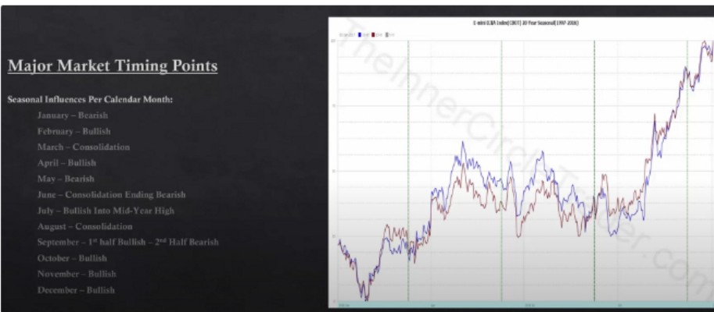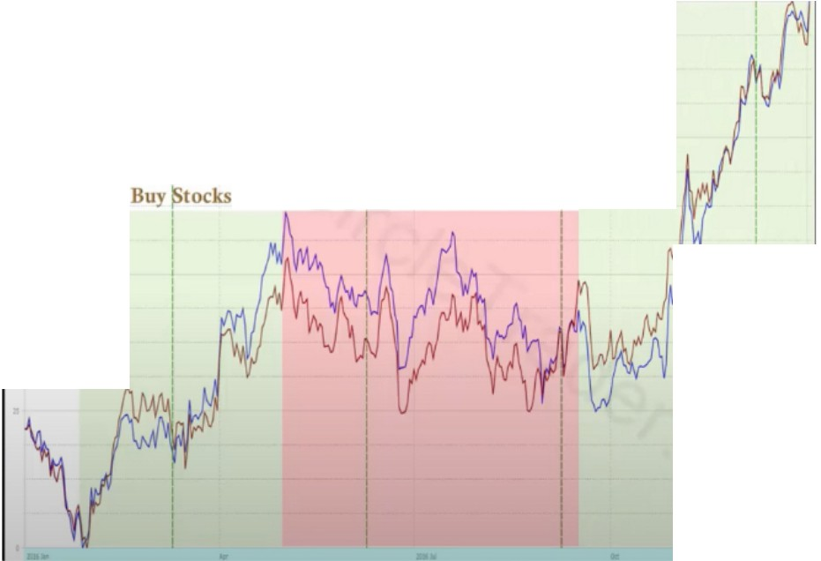

**1..ao.ui.a(OOl)Jf tflll·Jlllt)**

Buy Stocks

Sell Stocks

The rules on when to buy and when to sell/short

Darlings of the dow, dogs of the dow

Sometimes IBD will put out strong fundamental stocks, but they dont have the technicals to support it and now new thing happened so theres no institutions drawn to it. We need institutions behind the move

We look for quick eplosive runs in growth stocks, they can go up quick but they can also come down pretty quick

We dont aim for super long term holds, who makes the most money? The guys that holds waiting for it to go up or the one that swing trades it and pulls out profits and reinvests those profit?

Obviously the 2nd guy.

We want to capture swing trades in stocks, thats it

When we get a bullish divergence between the DOW NAS and SP in the beginning of the bullish periods, and we trade into a discount then we can apply all these concepts

Arjo I Twitter, lnstagram I Linktree

Linktree. Make your link do more.

, https://t.co/HhmmTN1fUI

JavaScript is not available.

*"JI* https://twitter.com/arjoio